08
Fall

Community Board 3 State Liquor Authority Committee Policy Review

Final policy as voted on
February 2011

Table of Contents
Executive Summary 3-4
SLA Committee Criteria 4-6
Best Practices 6-7
500-Foot Rule and Public Benefit 7-8
New Stipulations Recommendations 8-10
Zoning Policy Recommendations 10-11
New Transfer Policy Recommendations 11-12
New Procedures Recommendation 12-13
Resolution Area Recommendation 13-14
Conclusion 14-15
Appendix A 16
Appendix B 17-18
References 18

Report Prepared by: Paul Costa

Executive Summary
Background:
Community Board 3(CB3) has seen an increase in the amount of liquor-licensed establishments in the area, which include bars, clubs, lounges and restaurants. The increase in these nightlife establishments has caused numerous quality of life issues within the community. Residents have complained about noise, traffic, sanitation and a lack of retail diversity within the community. Additionally, because of the increase in liquor license applications, the committee and the community board office has become over-tasked with the challenge of evaluating each liquor license fairly and providing support to the community. The committee’s responsibility is to provide the State Liquor Authority (SLA) with a recommendation as to whether or not the community approves or denies the applicant. Applicants and critics have complained of the lack of consistency in how applications are evaluated and resolved. While the Committee can deny the applicant, the SLA still has the final vote, leaving some of the decision making out of the hands of the community.

This project was set up to review New York SLA policies and how CB 3 should consider them, to assist the CB in reevaluating the current SLA Committee policies, and to reevaluate policies so that these policies can help reduce quality of life issues. Input came from special meetings held in July, and September, practices of other Community Boards and 9th Precinct meetings, in addition to written testimony, community surveys and SLA Committee meetings.

Recommendations:

- Adopt a set of criteria that each applicant will be reviewed under to provide the committee with relatively consistent parameters to evaluate if the applicant will be a good neighbor.

- An SLA Policies & Procedures Taskforce, aka the “Taskforce” should be established to implement the above recommendations along the guidelines found herein.

- Create a “Best Practices” for businesses with liquor licenses to follow that address quality of life issues.

- The Community Board should define a “Public Benefit” as “a business where the majority of the operation is providing the local community with a good or service that is in need by the community, provides unique goods or services not already in the community, provides a cultural benefit, increases retail diversity, enhances the quality of life of the residents or is a conscientious business that will be a stabilizing force to the surrounding area.”

- The Committee should continue to follow the 500 Foot-rule policies that have been established and review an applicant under these guidelines.

- The Committee should develop a “High Density” area criteria wherein if there are a set number of licenses within 500 feet, if the applicant falls under the High Density area they must clearly define the “public benefit” of having a liquor license.

- The Committee should adopt a pilot program of a “standard” set of stipulations, above Houston Street, that new license establishments should follow. The stipulations will be based on the zoning district the business falls under.

- The Committee should work with the Lower Eastside BID, and other business and commercial organizations below Houston Street, to develop stipulations that best fit this commercially zoned section of CB3.

- Revise current SLA application to follow committee criteria and include stipulations in the application, which the applicant must agree on.

- The committee should maintain it’s zoning policy on eating and drinking establishments in residentially zoned districts.

- The committee should establish a “grandfathered” transfer policy for business that have been established before a certain time period. These grandfathered businesses will be able to transfer their license with the existing stipulations. The business will only be a “grandfathered” business, if they adopt the Best Practices. The grandfathered policy will apply only to those businesses that do not have complaints.

- The SLA Committee should review each transfer that does not fall under the “grandfathered” statue as a new applicant and evaluate the transfer on the new set of criteria and put in place the new stipulations.

- Any license that has been inactive for two years will be treated as a new applicant and the grandfathered clause will also be void.

- Reevaluate the current Resolution Zones, based on a stronger set of criteria that will allow the SLA Committee to review the Resolution Zones periodically under the same criteria.

Criteria:

The SLA committee’s responsibility is to provide each applicant a fair hearing and make a decision to approve or deny an applicant based on what is best for the community. Each applicant brings a different set of variables to the hearing, providing the committee with the task of reviewing each applicant fairly on these variables while keeping precedent and the community in mind. The committee does an excellent job of this task, but due to a general lack of established documented criteria, there are some discrepancies within the community on what should and should not be approved.

Testimony:
During the public hearings, testimony showed that there have been complaints about a lack of consistently applied criteria in evaluating applications. One applicant once jokingly stated he got approved because he was wearing a tie. The lack of established criteria has also been cited as a source of complication with the community since approvals can vary from meeting to meeting depending upon the differing opinions of the committee members and the different constituency of the committee from meeting to meeting, frustrating the community. Other testimony showed support for a set of standard criteria that will allow for equal and consistent review of each applicant.

Committee:
The Committee members have differing opinions on what the best criteria are for reviewing an applicant. This may cause a certain criteria being weighed more than others. The main theme around the committee’s criteria is to gain enough information to help discover if the applicant will be an asset to the community or amplify the issues already stemming from the numerous liquor licenses.

Community Boards:
Community Board 4 is one CB that has a documented set of criteria for both the community and applicant to review. The criterion is for the Rear Yard/Roof Top liquor license policy. CB4 has found that these areas have caused similar quality of life issues to those of CB3, such as noise. The committee looks at a set of criteria for approval and provides set stipulations that the applicant must adhere to. It allows for open transparency and creates standards that the applicant must follow; but as mentioned, this is only for backyard and roof licenses. CB7 does not have set criteria for applicants but agrees to look specifically at how a new license may affect the quality of life, with stipulations to address these issues.

Recommendations:
It is our recommendation that the SLA Committee follow the below criteria or a similar structure that allows the committee to review each applicant with consistency and with the community’s best interest in mind. The committee should break each criterion into four categories, with each category having standard questions in each that the applicant must answer: Location, Business Operations, Applicant History, and Community Involvement. Additionally, while the present application has a checklist of documents requested in addition to the application, the revised application should have a coversheet with an expanded checklist of the additional items the committee needs to review an application at the scheduled committee hearing. If parts of the checklist or missing the applicant can chose to be reviewed the following month or be reviewed with the incomplete application, knowing that they may be denied due to lack of information.

Location:
- Make up of businesses around new business
  - Look at businesses nearby: is there a concentration of the same businesses?
  - Does it fall under the 500-foot rule?
  - Map of block showing both sides of the street
- Street (measured from zoning lot line to zoning lot line)
  - Narrow- a street less than 75 feet wide
  - Wide – a street more than 75 feet wide
- Zoning
  - Commercial
  - Commercial overlay
  - Residential
    - Is space grandfathered in as non-conforming?
- Location Complaints
Business Operations:
- Type of business
  - Bar
  - Restaurant
  - Bar/Restaurant
  - Club/Lounge
- Hours of operation
  - Are they acceptable for the stated business?
  - Do hours of operations adhere to stipulations?
- Façade hours
  - Do they adhere to the committee’s new stipulations?
- Number of Patrons/seats
- Noise Control
  - Music
    - What type?
      - Live
      - Speakers
      - Promoted events or events where cover fees are charged
- Soundproofing
  - Will steps be taken to control the sound from:
    - Music?
    - Outside noise?
    - Noise from establishment?
- Crowd and Traffic control
- Security
  - Is there a security plan?
- Serving Food
  - Yes- What are the kitchen hours
- Is there a version of the business plan that can be shared with CB3?
Applicant History
- Experience of applicant or business owners
  - Experience in the community?
  - Experience owning an establishment?
  - Experience working in same type of business in NYC?
- Does applicant have other businesses
  - In the community?
  - In NYC?
- SLA violations
  - How many SLA Violations has applicant had in the past 3 years?
Community Involvement
- Did applicant provide outreach to neighborhood/block associations?
- Is there community support or opposition?
  - How many people signed the petitions?
  - Receive Block Association support?
- 500 Foot Rule
  - Give Public Benefit
Results:
By having these set criteria and an application checklist it allows for the applicant to be reviewed on four categories that are consistent for each applicant. The criteria and checklist also ensure that the committee can accurately judge if the applicant will be beneficial to the community. The criteria will specifically help address the quality of life issues that residents have continued to voice over the years. It also gives the committee a structure to review the applicant and will not vary from each meeting or each committee member. In addition, the criteria and checklist allow the applicant to know what information they will need to present and what questions will be asked during the hearing.

Best Practices:

Testimony:
Many of the residents have complained about quality of life issues that have been a result of the increase in nightlife establishments, but also about an overall degradation of street conditions and a resulting impact on their quality of life. Additionally, the residents at the testimony voiced concerns about a few select liquor license establishments that have been a key contributor to the quality of life issues. This leaves many qualified, well-run establishments being blamed for the actions of a select few. Various owners of establishments were present at the testimony, detailing that they are actively participating in mitigating the quality of life issues and very open to working with the community.

Recommendations:
It is our recommendation that the SLA Policy & Procedures Taskforce create a “Best Practices” guide to be followed by the nightlife establishments. The SLA Committee has stakeholders from both the community and nightlife establishment owners that will allow the committee to create “Best Practices” with a diversified input from the stakeholders in the community.

The Best Practices should be ways that the nightlife establishments could eliminate quality of life issues raised by residents during the testimony, summarized above. These practices would be created to give the nightlife establishment owners a guideline or standard to follow, based on the license they have or establishment they run.
Best Practices should focus on:
- Location
  - Practices for residential areas vs. commercial areas
  - Maintenance of space
  - Cleanliness of sidewalk and space
- Business
  - Noise Control
    - Closing facade
    - Proper use of outdoor space
    - Sound proofing when possible
  - Music
  - Hours of operation
  - Crowd Control
  - Security
    - Follow NYPD Nightlife Establishment guidelines
- Community Involvement
  - Have open communication with community
  - Following agreement with block association/community organization
  - Attend community meetings

An additional step once the best practices are in place would be to issue certificates or awards to those businesses following the Best Practices, which would signify to residents that they are working with and are beneficial to the community.
Results:
Setting up the Best Practices will provide a template for new and existing nightlife establishments to follow. It will also begin to single out many of the businesses that cause problems allowing for the police to better enforce and respond to complaints.
500-Foot Rule and Public Benefit
Part of the committee’s policy is to review if the applicant falls under the 500-foot rule set forth by the State Liquor Authority. The rule contains restrictions for new on-premise liquor licenses if there are three or more existing premises with full liquor licenses within 500 feet of the proposed establishment (SLA, 2006). If the applicant falls under this rule, then they must attend to a 500-Foot hearing with the NYSLA. If the applicant can show public interest or a public benefit, then the NYSLA can approve or deny the applicant based on the hearing, as well as community testimony.

Testimony:
Public Benefit
Residents were asked what they would consider a public interest or public benefit of having an additional licensed establishment in an area where there are already numerous licensed businesses. The resident survey was mixed in the response to this question. Some residents voiced the desire to see no new licenses because they provided no public benefit, while other results from the survey showed residents see good restaurants with food or music choices are a community benefit. Through the survey, residents defined a public benefit as a business that was an asset to the community and not another license that contributes to the problems in the community. Many residents do not see any public benefit of having more licenses when the area already has more than 3 licenses within 500 feet. Suggestions from the public were to better enforce the 500-foot rule and to define a better definition of a public interest or public benefit.

500-Foot Rule
Some of the comments from the public testimony discussed how ineffective the 500-foot rule really is due to a lack of enforcement by the SLA and the CB Committee. There are areas in CB3 with over 25 licenses within 500 feet, well beyond what the SLA rule states. The majority of the testimony about the 500-Foot rule focused on the fact that the concentration of liquor licenses in those areas goes beyond what is beneficial for the community. One speaker stated that the Lower East Side has the second highest number of liquor licenses per square foot in the country.

Landlords
Discussion between bar owners and committee members raised the matter of how landlords are involved in the current and future landscape of licensing in the community. The feeling is that while residents and nightlife owners struggle at times to co-exist, landlords who may be central to the proliferation as well as refuse to assist with helping to mitigate quality of life problems are completely absent. There was a question of whether they could be influenced to diversify their leases and/or working with the nightlife owner and residents to provide soundproofing.

Recommendation:

Public Benefit
In the absence of the NY SLA adequately defining “Public Benefit,” it is our recommendation that Public Benefit should be defined as: “a business where the majority of the operation is providing:
- the local community with a good or service that is in need by the community,
- provides unique goods or services not already in the community
- provides a cultural benefit, increases retail diversity
- Enhances the quality of life of the residents.
- Is a conscientious business owner acting as stabilizing force

This definition should be utilized in areas where the Taskforce has evaluated the resolution area and/or found a very “high density” and established a “trigger” for when the saturation has crossed a to-be-determined level above what is normally covered by the 500 Foot Rule, e.g. when there are [TBD #] full liquor licenses within 500 Ft., a new applicant must fit the above definition.

It has been ruled in court that a “public benefit” cannot be jobs or taxes.

It is our recommendation that along with the Public Benefit, the SLA Committee enforces the current 500-foot policy that has been establishment by this community board.

500-Foot Rule
It is our recommendation that the committee develop a “high density” alert, based on the number of licenses in a particular area. The alert will be triggered when an applicant is applying for a license and there are already a set number of licenses within 500 feet of the proposed establishment. The committee could potentially develop an index for these “High Density” zones. The zones will be a number index, with both beer and wine licenses as well as full liquor licenses having separate numerical values. For a more in depth analysis, numerical values can be given to establishments with later closing hours, size of establishments, type of establishments, resident population in the area, etc.

It is our recommendation that if the applicant falls within this alert, they should have to provide their definition of “Public Benefit” to the SLA Committee. The committee should review the application and make sure that the proposed benefit fits the definition of the Public Benefit, adheres to all of the “best practices” and meets the criteria that will be established.

Landlords
The Taskforce should develop a process and letter to be sent to well known landlords in the community, their attorneys, and/or managing agents notifying them of our criteria/guidelines for granting licenses. It may be a requirement of the applicant to receive a letter of acknowledgement from the landlord. The goal would be to try and engage landlords more and let them know the seriousness that the Board takes with its resolution areas.

Result:
Providing criteria for, examples of and exclusions from a “public benefit” will allow the committee to review an applicant and to see if they are truly providing a “public benefit” to the community. It also allows the community to see what benefit the business will have for the community. The addition of the “high density” alert will allow the committee to find high density areas and evaluate the applicant with a stricter set of criteria due to the density of the licenses. The High Density zones could also potentially allow for the removal of the Resolution Areas.

Stipulations:
When the CB approves an applicant for a license or renewal, the applicant may have to agree to certain stipulations that have to be followed or the committee will ask the SLA to deny the applicant their liquor license. The stipulations govern how the business will operate such as: hours of operations, façade operations, and types of bars, security, type of music, etc. By having these stipulations it requires the business to operate as it has advertised itself to the committee and the community. The stipulations also help the committee work with the applicant to mitigate the quality of life issues in the community before and after they arise.

Testimony:
During the testimony, many of residents expressed a lack of understanding of the stipulations. Statements from residents showed that they didn’t know each establishment’s stipulations and it was difficult to find out what they were. There was also a distrust between the residents and nightlife establishments; the testimony reflected a sentiment that once an applicant accepts the stipulations they will do what they want, ignoring the stipulations in place. The testimony showed that the community supports the business if the stipulations on hours, music and façade were in place to mitigate the quality of life issues. Suggestions from the testimony included setting standard stipulations and stricter enforcement of the stipulations.

Committee:
Although there is a written list of common stipulations made, there is no standard set of stipulations that the SLA committee follows, since the committee reviews each applicant fairly and with the same due process. Stipulations vary from business type such as bar vs. restaurant, to different stipulations for each type of license. Each applicant has to agree to a set of stipulations upon being approved by the committee. Once each stipulation is agreed upon the committee has to vote and fill out the stipulation form, which needs to be signed and notarized. This process takes time, causing delays during the meetings.

Community Boards:
Community Board 4 has certain stipulations in the application package, which are agreed upon by the applicant without debate. When the applicant fills out the application they know how they will have to operate certain parts of their business, and if they can’t do so they may not get approved.

Recommendations
It is our recommendation that the committee create a standard set of stipulations based on the zoning district the business is established in and the license that they are requesting. This should be done in stages with the first stage done as a pilot program, above Houston. The stipulations should also reflect the “Best Practices” that a liquor establishment should follow. These stipulations are to be agreed upon in the application; if the applicant agrees to all stipulations the committee should approve the application without an issue. If the applicant does not agree they must explain to the committee why and what are they doing to control the quality of life issues that stem from not following these stipulations.

The stipulations should be based on the zoning district and type of license since these are two standard criteria in the community and cannot vary for each applicant. It also establishes continuity in these zoned areas.
For example the SLA Committee can set up and post a Matrix similar to this:
(This as an example the SLA Taskforce Committee will establish stipulations)
 | Full Liquor License | Beer and Wine
Residential  R7-2, R7A, R8B, R8 | Hours of Operation: no later then 2:30am  Façade: Close all façade by 10pm  Music: No live music | Method of Operation:  Hours of Operation: No later then 11:00pm  Façade: Close all façade by 10pm  Music: No live music
Commercial Overlay  C1-5, C2-5 | Hours of Operation: no later then 2:30am  Façade: Close all façade by 10pm  Music: No live music | Method of Operation:  Hours of Operation: No later then 11:00pm  Façade: Close all façade by 10pm  Music: No live music
Commercial District  C1-6A, C1-7, C1-8, C4-4A, C6-2A, C6-3 | Hours of Operation: No later then 4:00am  Façade: Close all façade by 11pm  Music: Any music | Method of Operation:  Hours of Operation: No later then 2:00am  Façade: Close all façade by 11pm  Music: No live music

Stricter stipulations should be put on applicants that will be opening a business in areas that are zoned R7-2, R8B, and R7B from North of Houston to 14th Street and East of 3rd Avenue to the FDR Drive. These residential zoning districts are sections of CB3 with the most frequent complaints from residents. These areas are heavily residential on narrow streets, with commercial space on the ground floor. This space under normal zoning regulations would not be used as commercial but under prior zoning law the space was allowed for commercial use. These spaces are then grandfathered in under that use and are considered legal non-conforming. Due to the high residential populations the stipulations should follow the NYC Department of Environmental Protection noise control guidelines and make businesses limit business operations between the hours of 10 P.M. and 7 A.M.

It is our also our recommendation that the Taskforce works with the Lower East Side Business Improvement District and other organizations, to developed stipulations in the commercial zoned districts below Houston. The area below Houston has commercial zoning districts and the stipulations should reflect the business and commercial environment in that area, rather then the stipulations above Houston where it is zoned for a mixed use of residential and commercial.

The Taskforce should implement a trial period of between six months to one year to understand the impacts of creating such a policy based on zoning. The Taskforce should survey both residents and bar owners within the new stipulations areas to help gauge the impact of the new policies. In addition to the surveys, the taskforce should look at 311 complaints with action and NYSSLA Complaints.

Results:
By setting up standard stipulations it allows the committee to mitigate some of the quality of life issues in the community. The increased transparency of the stipulations will allow for the community to know how the business should operate limiting some confusion from the community. In addition it will allow for applicants to know what type of stipulations they must agree upon based on the license they are applying for and the zoning they are in.
Zoning Policy:
The SLA Committee has an existing policy to deny new applicants in areas that are not zoned for commercial use. This policy was adopted because the Lower East Side, is unlike many areas in Manhattan and has a significant amount of non-confirming commercial space in zoning districts that are zoned strictly for residential use and prohibit any commercial uses. These spaces have been grandfathered in by the city, since they were in use before the Department of City Planning made a zoning text amendment in these areas. The commercial use is permitted until the space has been vacant for a “continuous period of two years the non-conforming use is discontinued. “(NYCDCP, 52-61)

Testimony:
During the public hearings a fair amount of the testimony was complaints by residents living next to these non-conforming uses within a residentially zoned district. Additionally many of the problematic areas within the community are these areas with the non-conforming uses.

Committee:
The committee maintains its zoning policy and has enforced it, but at times has allowed for an applicant to be approved. This can be because it is not recognized that the applicant is asking for a license in a residentially zoned district, which could be caused by the applicant never addressing the question in the application or the applicant can be approved because the space is already licensed and another applicant will be accruing the space and the committee knows that this spot is not an issue with the community.

Recommendation:
It is our recommendation that the committee maintain its policy on denying any new eating and drinking establishments that are not currently an eating and drinking establishment in residentially zoned area, which are R7 and R8 districts. The committee should reject to the SLA that under NYC Department of City Planning, eating and drinking establishments, which are Use Group 6, are prohibited in R7 and R8 residentially zoned districts.

It is also our recommendation that the committee continues to deny any applicant that wishes to use any outdoor space within a non-conforming use in a Residential district. NYC Zoning text states that eating and drinking establishments in a non-conforming use within a residential district must be in a completely enclosed building. (NYCDCP, 52-31)

Results:
By strictly following the committee’s current policy of not approving additional drinking and eating establishments in residential areas, it will allow for grandfather spaces to become a conforming use. It also allows space between residents and the commercial spaces. By eliminating some of these commercial spaces in residential areas it has the potential to limit some of the complaints residents have had in these areas.

Transfers Policy:
SLA policy allows an applicant purchasing an existing licensed business to apply for a temporary license immediately so that the operation of the location can continue without interruption. This allows for the same address to remain the same use and the liquor license to remain in circulation on a temporary basis during the application procedure. The SLA: “staff uses the terms “transfer” and “new” applications only to differentiate between an application for an establishment that is currently licensed and selling their business (transfer) and an establishment that is not currently licensed (new). In both cases, the license applicant must go through the same process, including notifying their CB and holding a 500 foot-hearing if applicable.” (SLA, 2006)

Testimony:
The testimony voiced concern that this policy keeps the license in circulation and does not help reduce the concentration of liquor licenses in an area. There is also confusion on what the process is with a transfer of license, since there is no set policy on transfers. The testimony from nightlife establishment owners was that the license transfer is an important asset to their business. They should be able to transfer the license without conflict. The testimony showed that there is a strong confusion within the community, the committee and the applicants on what is a transfer and how it should be treated.

Committee:
The committee is mixed on the transfer procedures, since there is no formal policy on how to review the transfers. Some SLA committee members see the transfers as key for a business, because they are seen as an asset to the business and thus should be able to sell the license if they choose to. The committee also agrees with the community that transfers should be treated as new applicants because each new license has the potential to change the character of the block and impact the community. However, there has been a perception in CB 3 until recently that transfers should be treated differently than new licenses. Motions passed by the committee and full board have enforced this perception.

Community Board Policy:
Various other CB’s were surveyed to understand how they process “transfers” for liquor licenses. Each CB views a transfer as a new application, while CB1 treats each on an individual basis with only establishments that have problems needing review as a new license.

Recommendations:
Considering the other Community Boards transfer policies and how the NYSLA considers transfers as new licenses, CB 3’s SLA Committee must start to carefully and gradually change the current defacto policy of not reviewing transfers as new applications. Instead the CBs SLA Committee must move towards a policy of reviewing each transfer as a new applicant. It is our recommendation that the committee develops a “grandfathered” policy whereas for any business that has been established before this time, the transfer to the new applicant will be allowed as long as they maintain the current stipulations and operations regardless of the new policies and stipulations established as a result of this report and subsequent Taskforce. By doing this it will allow for a gradual change of the current SLA Committee’s transfer policy, and prevent any existing business experiencing any hardships due to the policy change. However, part of this grandfather policy is that the existing business must adopt the Best Practices that have been established. The “grandfather” status will only be available to businesses, which the SLA Committee reviews and is seen to be a responsible business owner, through reviewing, SLA Complaints, NYPD Violations and 311 Complaints with action.

While not a NYSLA policy, the SLA Committee must be firm with denying transfers where there is a major change in the method of operations since the new operations may have a negative impact on the community and should thus be treated as a new license. Additionally, the Committee should still evaluate if the new applicant is experienced and the “right fit” for managing the business even if the method of operation remains the same. The intention of "right fit" is that the future business owner appears to be experienced and responsible for managing the business with the same method of operation, will be a good neighbor, and does not have violations within the last two years of any business he/she owns or is the general manager. In sum, it is a dual responsibility of both the existing establishment and the new applicant to prove a clean record in order for the “grandfathered transfer” to be approved and treated as a “transfer.”Any applicant appearing before the committee regarding a transfer license must be accompanied by the current business owner (seller) or bring a letter from seller stating that business assets are being sold to this applicant.

It is our recommendation that the committee reviews all transfers that are not grandfathered as “new applicants” so applicant must then go through the same procedures as a new applicant, based on SLA stating that “both cases, the license applicant must go through the same process, including notifying their CB and hold a 500 foot-hearing if applicable”(SLA, 2006).

It is our recommendation that any license that has been inactive for more then 2 years be treated as a new applicant.

Results:
The new transfer policy will allow for CB3 to move to a policy that is more consistent with all of Manhattan and the SLA, in treating each transfer as a “new license”. By grandfathering in the existing businesses you allow these businesses to be able to continue to operate under the old policy, eliminating any hardship in maintaining and selling their business. The new policy should eliminate some of the concern that approving a new license in an problematic area, will just result in another license in the area. Going forward, any new license holder who seeks to transfer it in the future should expect that the new applicant will be subject to the same approval process for a new license.
Procedures:

The SLA Committee does a great job of reviewing the large amount of applications they receive each month. They give each applicant a fair hearing and provide feedback to the applicant. However, many of these meetings stretch long into the night, taking up the valuable time of the committee and the community. More can be done to streamline these meetings and make them more efficient.

Testimony:
There was a limited amount of testimony on the procedures and process of the meetings. Residents voiced their concern that the meetings were too long and unfair to the committee members. There was also testimony that there was too much advising of the applicant on how to get approved, as well as debating of issues. The community had suggestions on improving the process, by creating two committees north and south of Houston Street, and also reviewing applications before the meeting and posting information on-line.

Community Boards:
Each CB has a different procedure for their SLA Meetings, these variations are due to the number of applicants the CB receives each month and policies that are in place. Each CB also has a different SLA application, with each applicant asking a varying degree of information from the applicant. Community Board 4 has an application that has stipulations placed within the application, which the applicant must agree upon while filling out the application. Additionally, CB4 has also split up their SLA committee meetings into two different geographic areas, allowing for shorter meetings and a more focused criteria based on the geographic area.

Recommendations:

The first recommendation is to create a Community Board SLA Task Force, which will be comprised of the SLA Committee members to develop the needed documentation of the new policies and to enforce the recommendations within this paper.

The second recommendation is to change the application to reflect the criteria that will be agreed upon by the Committee and that the application should follow the four categories of: Location, Business Operations, Applicant History and Community Involvement. Additionally the application should have the applicant agreeing on stipulations in the application, very similar to CB4 application. This will prevent the committee from having to produce a stipulation agreement once the stipulations have been agreed upon. The application can then be signed and notarized.

It is our recommendation that the CB provide a link on the CB website and the applicant to http://gis.nyc.gov/doitt/nycitymap/, where the applicant can type in their address and review all the building and property information needed for the application. Instructions on how to obtain this information are in Appendix B.

The third recommendation is to follow a more structured flow of the meeting (see appendix A). The flow of the hearing should be the same for each applicant. Once the application is reviewed, the committee should move to ask additional questions if the applicant does not agree with the stipulations. If the committee has questions each member can ask the questions. If there are no questions a motion should follow. Once a motion has been passed or denied the decision should be final, limiting any other discussion or debate with the applicant. The meetings should go faster once an established criteria and stipulation is in place as well.

The last recommendation is to review the committee meetings once the new criteria, stipulations and criteria are in place. If the meetings continue to be lengthy then the committee should be split up into two geographic areas North of Houston and South of Houston. This should be the last option if the meetings do not improve as it creates two committees and potential redundancies and additional work for the Community Board Staff.

Results:
Creating an application that better displays that the criteria the committee is looking at and includes stipulations should help streamline the meeting process. It will allow for easier review of the applicant and easier completion of the necessary paperwork. Additionally, following a structured format should make the meetings more consistent and move quicker by eliminating and discussion and confusion.

Resolution Area:
The Resolution Areas (RA) are geographic areas within CB3, where there is a high concentration of liquor license establishments and documented quality of life and enforcement issues such as; noise, increase in vehicle and pedestrian traffic, sanitation issues and a lack of adequate retail services. Due to the amplified quality of life issues within these geographic areas, the committee believes that licenses in these areas should be denied because of the ongoing issues. The SLA Committee’s policy is to hear applicants with new licenses in these areas, but only approve them if there is a demonstrated public benefit or substantial support from the community.

Testimony:
Throughout the testimony RA’s were discussed, the public sees the RA as areas within CB3 that should be exempt from applicants being granted any new liquor licenses. The sentiment during the testimony is that these areas are “saturated” with licenses already and causing many quality of life issues with the RA’s. Residents raised concern of the effectiveness of the RA, they believed RA’s were put in place to limit additional licenses and control the secondary effects of these nightlife establishments and the RA’s are not doing this, especially when licenses are still being approved in the RA’s.

There was also testimony that the RA’s be abolished, that the policy is not beneficial to the business community. Opponents of the RA’s feel that the RA should be carefully reviewed and possibly be revoked in some areas. The RA’s also affects business; some businesses do not want to come into the area for fear of retribution from the community if they do open there.

Committee:
One issue within the committee is the lack of consistency with the approval of applicants within the RA’s. While these are areas where it is recognized that liquor license should be denied, applicants are sometimes being approved with inconsistency, although with more stringent requirements and criteria. The committee has approved an application if a establishment is reasonable such as a restaurant, provides community outreach, has a clean record from their other businesses, a recommendation from other CB or community, or there is a relatively low concentration of licensed establishments in the immediate vicinity and a well-thought-out business plan that shows the committee they are committed to the business. The committee believes the RA’s are necessary and are a good policy, but may need to be reviewed to include more areas or remove areas.

Recommendations:

It is our recommendation that the Resolution Areas be reevaluated based on a set of criteria that provides more concrete evidence that these areas are experiencing significant quality of life issues and that these areas have the potential to impact a significant portion of the community. The criteria that the SLA Committee should look at are:
- Zoning District
  - Residential
  - Commercial overlay
  - Commercial
- Concentration of liquor licenses
- Retail Diversity of area
- Current Uses of storefronts and commercial space in Resolution Area (Land Use Survey)
- Residential population of Resolution Area
- Housing density of Resolution Area
- Noise complaints
  - Noise level at night
  - 311 complaints with action
  - Complaints to CB
- Nightlife Traffic
  - Pedestrian
  - Vehicle
- Is there any criminal activity of area

The committee should also compare the above criteria to a non-resolution area as a way of comparing the RA’s to a non-RA, allowing for a fair assessment of the resolution areas.

Results:
By reevaluating the Resolution areas, it will allow for the committee to review the zones based on a benchmark. This could allow for the expansion or contraction of existing zones. It will also allow the committee to periodically review the zones with the same criteria. Allowing for a consistent review of the zones throughout time.

Conclusion:
The SLA Committee has done an excellent job in reviewing each applicant in a timely manner based on the numerous applicants being reviewed each month. The committee has also effectively used their powers to mitigate some of the quality of life issues in the community. The recommendations above will help the committee create a more standard policy to review applicants. It will create a uniform approval process and set up standard stipulations that will work to mitigate the quality of life issues in the community. Additionally by setting up the various “best practices” it will set a standard for nightlife establishments to follow that helps control the quality of life issues affecting the community. A final recommendation is that the SLA Policies and Procedures Taskforce create a “Handbook” for all SLA committee members to study and follow on a monthly basis.

Appendix A- Recommended SLA Committee Meeting Flow Chart

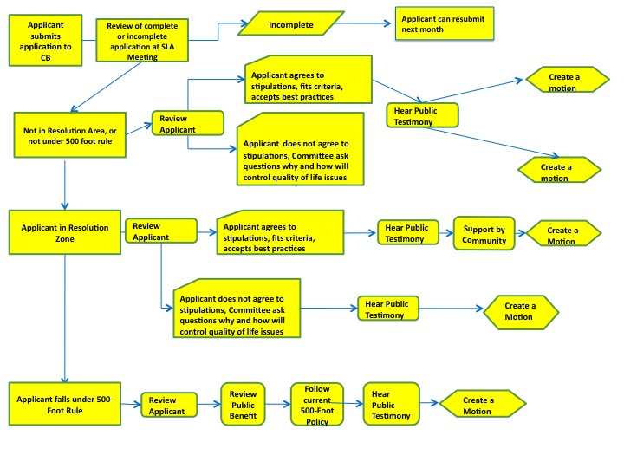

Appendix B http://gis.nyc.gov/doitt/nycitymap/
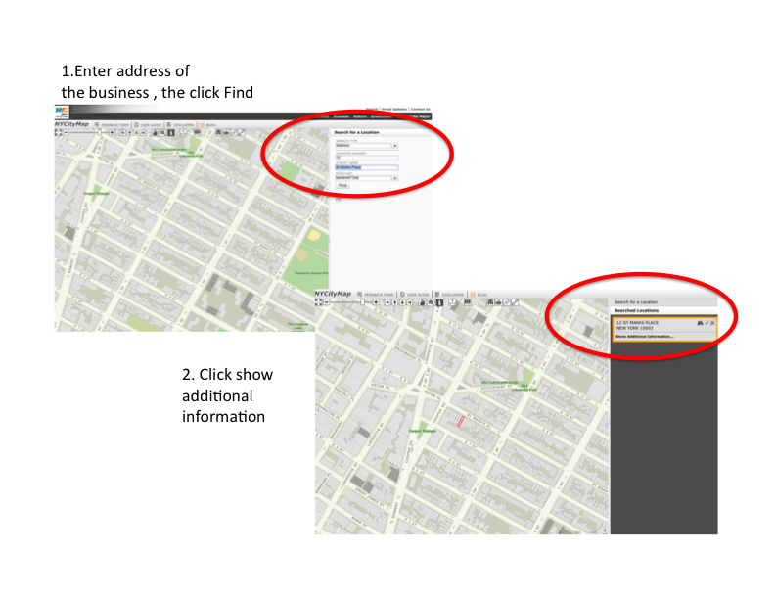

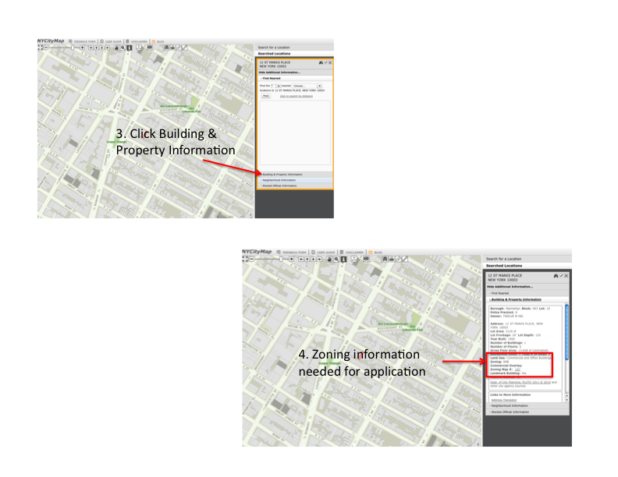

References:
City of Wilmington North Carolina. August 2010. City of Wilmington Central Business District Policies and Practices.

Manhattan Community Board 3. SLA Committee Policies http://www.nyc.gov/html/mancb3/html/sla/sla.shtml. Retrieved September 25 2010

Manhattan Community Board 3 “SLA Committee Hearing.” Date (9/27/2010)

Manhattan Community Board 3 “SLA Committee Hearing.” Date (8/19/2010)

New York City Department of City Planning. 2006. Zoning Handbook . Department of City
Planning

New York Police Department 9th Precinct “Community Affairs Meeting” Date (9/21/10)

New York State Liquor Authority. Taskforce for the Review of On-Premise Licensure December 8th, 2006

