
Flu season is coming...
Get your flu shot at work
Influenza - the flu - is a dangerous respiratory infection that spreads easily to others. Even healthy people can become seriously ill from the flu. The flu shot is the best way to protect yourself, your community, and your loved ones from this highly contagious illness.

Take 5 minutes out of your day to reduce your risk of catching the flu this year! Worksite flu shot clinics are quick, easy, free, and available across the City. Click below to register at the worksite closest to you!

Flu Fighter Pro Tips
Where can I get a flu shot?
NYC employees have four options for receiving their free flu shot: the workplace, participating pharmacies, in-network physicians and AdvantageCare Physicians (ACPNY) medical offices. Dependents and pre-Medicare retirees are also covered. Learn more here.

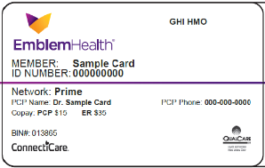
Be sure to give your medical card to the pharmacy!
Don’t see a clinic at your location?
Events are always being added, so keep an eye out for announcements from your agency/worksite or visit the citywide online scheduler here to find clinics close to you.
DCAS is hosting clinics at the Municipal Building (1 Centre St) for all City employees—walk-ins are welcome, but appointments are recommended:

- September 10th: 10:00am – 2:00pm
- October 4th: 10:00 am – 2:00pm
- November 8th: 10:00am – 2:00pm
- November 20th: 10:00am – 2:00pm
More questions?
Learn more here or email Work Well NYC at workwell@olr.nyc.gov.
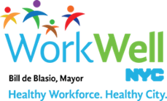
nyc.gov/workwellnyc + workwell@olr.nyc.gov

