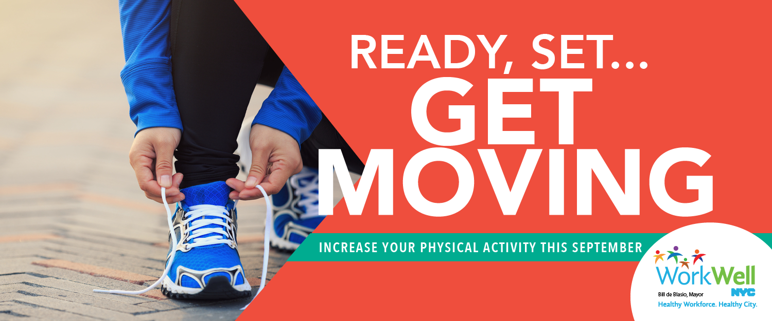

For many of us, walking may already be a part of our daily routine — but it can also be an easy way to sneak more physical activity into our daily lives. Whether you walk, run, bike or roll — [WorkWell NYC](https://on.nyc.gov/2CKxY8j) challenges you and offers you the tools to move more during September and beyond!

**______________________________________________________________________________**

**BENEFITS OF PHYSICAL ACTIVITY**

Some of the many health **benefits** to incorporating **physical activity** into your daily routine:

* Improves your mood
* Prevents many chronic diseases
* Maintains a healthy weight
* Sleep better
* Strengthens and protect bones, muscles, and joints

Adults should get at least 30 minutes of physical activity, five days a week. It doesn’t have to be all at once!

**______________________________________________________________________________**

**TIPS TO HELP YOU STAY ACTIVE**

|  |  |  |
| --- | --- | --- |
|  |  |  |
| **AT WORK** | **AT HOME** | **ON THE GO** |
| * Try these [chair stretches](https://on.nyc.gov/2wvDVzE) right at your seat! * Walk over to speak to your co-workers instead of calling or emailing | * Take a walk around the block after a meal * Keep busy – gardening, housework, and playing with kids or pets can increase your heart rate! | * Take the stairs instead of the elevator * Get off the bus or subway one stop early and walk the rest of the way |

Get more tips to move more throughout your day [here](https://on.nyc.gov/2x2HopO), and visit the [WorkWell NYC physical activity webpage](https://on.nyc.gov/2CKxY8j) for more information on physical activity resources and discounts available to City employees.

You can also check out the [Guide to Healthy Eating and Active Living in NYC](http://on.nyc.gov/2hFu56T) for more tips on how to stay active.

**______________________________________________________________________________**

**DO YOU KNOW YOUR HEART AGE?**

[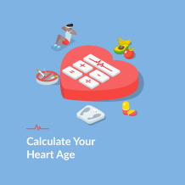](http://bit.ly/heartagecalc)Regular physical activity can help you keep your heart healthy.

Do you know your heart age? Heart age is the age of your heart and blood vessels. It can be the same or different from your actual age, depending on if you have risk factors for heart disease and stroke. Find out your heart age [here](http://bit.ly/heartagecalc).

**______________________________________________________________________________**

**[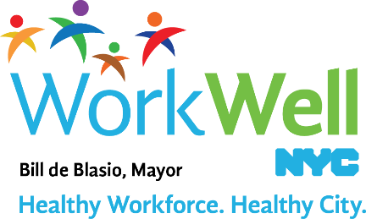](http://on.nyc.gov/2AFumj1)**

[**nyc.gov/workwellnyc**](http://on.nyc.gov/2AFumj1) **|** [**workwell@olr.nyc.gov**](mailto:workwell@olr.nyc.gov)