**World Trade Center Health Programs for 9/11 Responders and Survivors** September 11, 2018

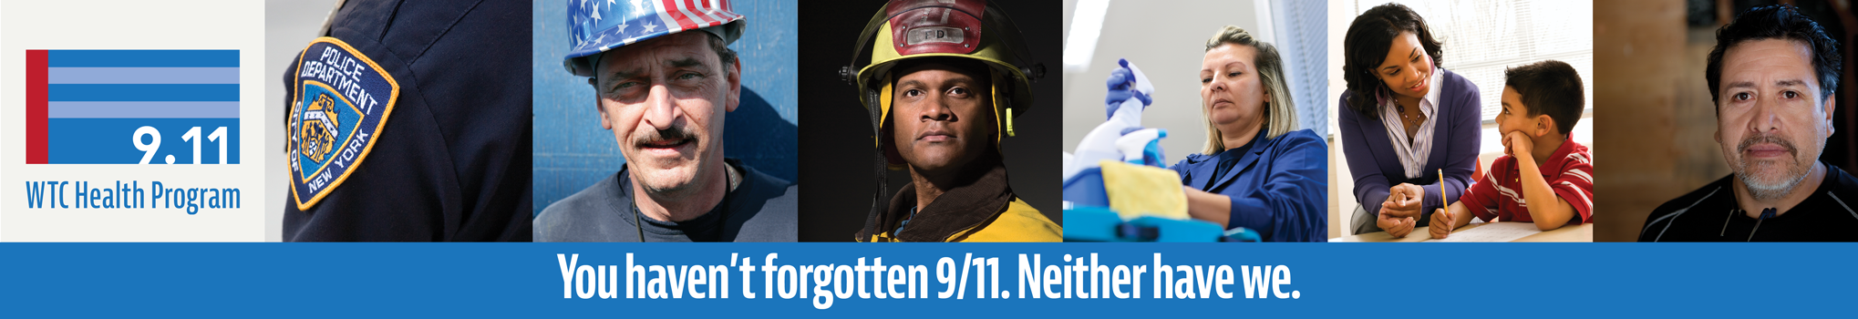

**World Trade Center Health Program – Medical Monitoring and Treatment**

The events of 9/11/01 continue to take a toll on the physical and mental health of those who were there 17 years ago.

The **World Trade Center (WTC) Health Program**, administered by the National Institute for Occupational Safety and Health (NIOSH), was established by the James Zadroga 9/11 Health and Compensation Act of 2010 to provide WTC-related physical and mental health benefits for 9/11 responders and survivors that qualify, including:

* NYPD and FDNY
* Emergency medical personnel
* Cleanup, rescue, and recovery workers
* Residents, workers, and students in Lower Manhattan during or shortly following 9/11

Over 88,000 responders and survivors have already enrolled in the program, with many receiving on-going care through the Clinical Centers of Excellence in the New York Metropolitan area and through the Nationwide Provider Network.

**Are you eligible?** [**Learn more**](https://go.usa.gov/xPagu) **about who qualifies, documentation requirements, and how to apply.**

**City employees who were exposed to the WTC disaster may take** [**excused absences**](https://www1.nyc.gov/site/911health/enrollees/wtc-excused-absence-policy.page) **to schedule an initial appointment at the WTC Health Program if they meet federal eligibility requirements.**

**The World Trade Center Health Registry**

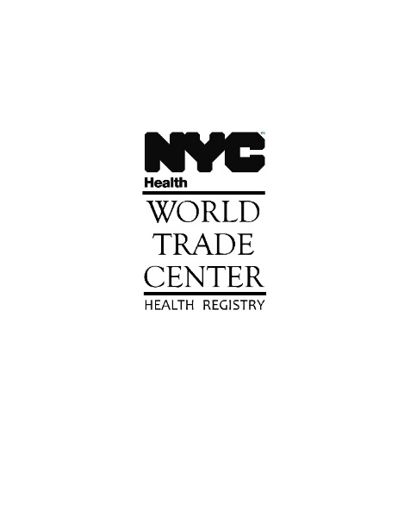

The WTC Health Registry conducts research on the health effects from the 9/11 events. Enrollment was open to responders and survivors from 2003 to 2004 and has been funded by NIOSH since 2009.

**To learn more about the WTC Health Registry and its 9/11 health research findings, visit the NYC DOHMH’s WTC Health Registry at** [**nyc.gov/911health**](http://www.nyc.gov/911health)**.**

*If you are enrolled in the WTC Health Registry, you are not automatically enrolled in the WTC Health Program.*

|  |
| --- |
| PLEASE DO NOT REPLY TO THIS MESSAGE |