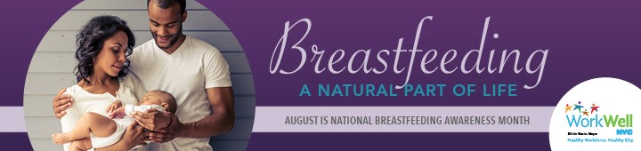
WorkWell NYC is here to support parents who are breastfeeding or plan to breastfeed, and to make sure you know your rights and take advantage of the free resources available to you.
  - Builds your baby’s immune system, reducing the risk of ear and respiratory infections  - Promotes brain development  - Speeds up parent’s recovery from pregnancy and childbirth  - Promotes bonding with your baby | 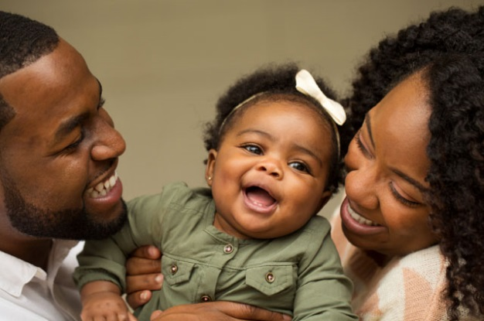

- Emblem Health members may receive coverage for the cost of renting or purchasing a breast pump, and for the Healthy Beginnings program, which provides assistance to expecting members who have experienced pregnancy-related complications or are managing other health conditions.
Call the number on the back of your health insurance card to learn more.

*Employees with other coverage should contact their insurer, or visit nyc.gov/hbp for more information.

- Baby-Friendly designated maternity facilities are compliant with the 10 steps to successful breastfeeding, including helping parents’ breastfeed within one hour of birth and allowing parents and infants to remain together 24 hours a day. For a list of designated maternity facilities, visit the Baby-Friendly USA facility locator.
- The Mobile Milk Breastfeeding Campaign provides free breastfeeding tips and information via text messaging. To sign up, text "MILK" to 877877. Text messages are delivered between 28 weeks of pregnancy and 4 months after giving birth.
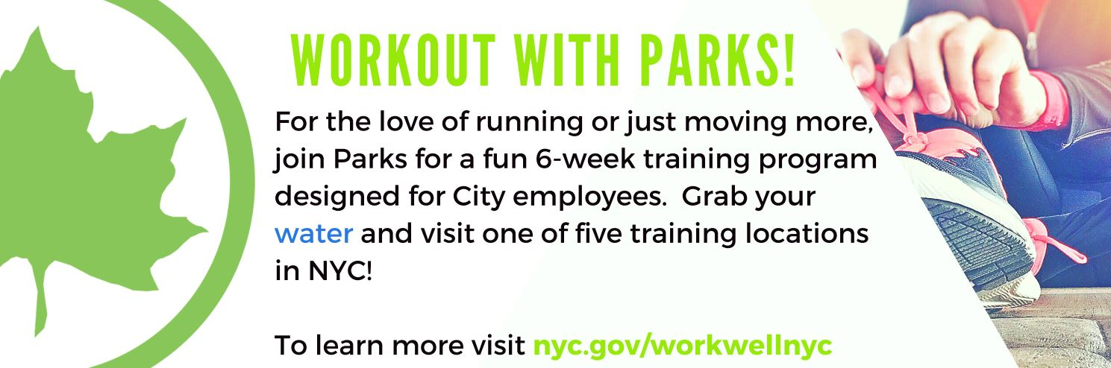
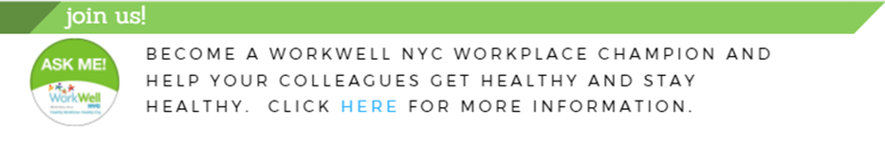
To learn more about infant feeding strategies and resources visit WorkWell NYC.
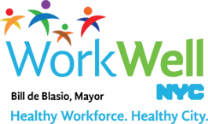
www.nyc.gov/workwellnyc | workwell@olr.nyc.gov

