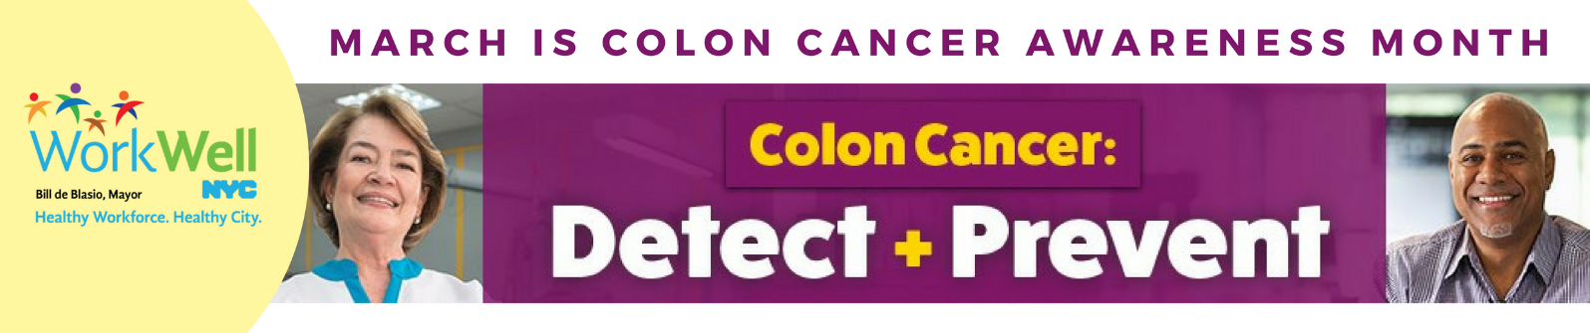
March is Colon Cancer Awareness Month. Colon cancer is the second leading cause of cancer death in NYC. The following lifestyle factors increase your colon cancer risk:
- Obesity
- Physical inactivity
- Smoking
- Drinking alcohol
TAKE THE FOLLOWING 6 STEPS TO REDUCE YOUR COLON CANCER RISK:
 | MAINTAIN A HEALTHY WEIGHT  Use the Guide to Healthy Eating and Active Living in NYC for tips on healthy eating and staying active. Benefit-eligible City employees and their families can also take advantage of the discounted Weight Watchers program.
 | BE ACTIVE  Shape Up NYC offers free fitness classes in all five boroughs.
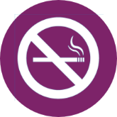 | QUIT SMOKING  NYC offers free resources to help you quit.
 | SEEK SUPPORT FOR RISKY DRINKING  If you think you or someone you care about has a problem with alcohol, help is available from the City and from the NYC Employee Assistance Program (EAP).
 | GET SCREENED  Talk with your doctor about the benefits and risks of colon cancer screening. If you don’t have a doctor, find one in your network here.
FIND MORE RESOURCES TO HELP YOU REDUCE YOUR RISK HERE.

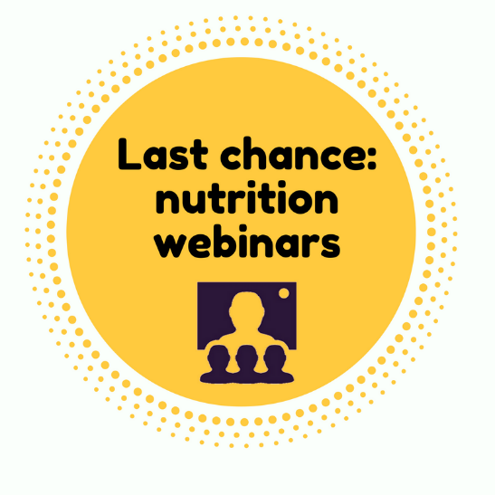 |  | UPCOMING WEBINARS:  What’s In Your Food? Reading and Understanding Food Labels  Tuesday, March 27 | 1:00 PM  Sip This, Not That: Exploring the Advantages of Healthy Drinks  Wednesday, March 28 | 12:30 PM

www.nyc.gov/workwellnyc| workwell@olr.nyc.gov

