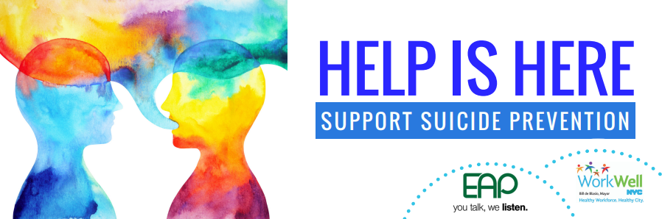
High-profile suicides have recently dominated the news. While suicide impacts people of all ages, genders, and financial circumstances, it also impacts families, communities and work environments. Suicide is also preventable.
While there are many barriers to getting help, City of New York employees can make a difference. The NYC EAP wants to support all NYC employees able to make a difference and offer a few suggestions to consider at your workplace:
 | PROMOTE CONNECTEDNESS AT THE WORKPLACE
- Conduct group supervision and staff meetings rather than 1:1 meetings
- Create or promote lunch time activities such as book clubs or walking groups
- Encourage staff to get to know one another by assigning group projects, establishing “employee resource groups”, and workplace newsletters
- Celebrate key milestones
 | REDUCE STIGMA
- Invite the Employee Assistance Program (EAP) to your workplace to address mental health and ways to reduce stigma
- Encourage help seeking behavior by promoting the resources available, such as NYC EAP (212-306-7660) and NYC Well (888-NYC-Well)
- Participate in a Mental Health First Aid training
 | BE PREPARED
- Know the warning signs of suicide by visiting this website
- Coordinate an onsite suicide prevention training
The NYC EAP will work with any employee to discuss how they can implement these ideas or others at their worksite.
Reach out if you know of anyone who needs help.

The New York City Employee Assistance Program (NYC EAP) offers free and confidential resources, support, and referrals to employees and their family members. Contact the EAP at 212-306-7660 or by email at eap@olr.nyc.gov.

NYC Well counselors are also available to help 24/7/365. Call 888-NYC-Well, text WELL to 65173 or visit www.nyc.gov/nycwell to chat online.
- Center for Disease Control: Preventing Suicide: A Technical Package of Policy, Programs, and Practices
- Suicide Prevention Resource Center
- Suicide Prevention Center of New York State

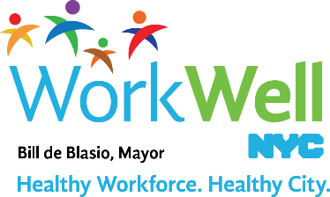
www.nyc.gov/workwellnyc | workwell@olr.nyc.gov

