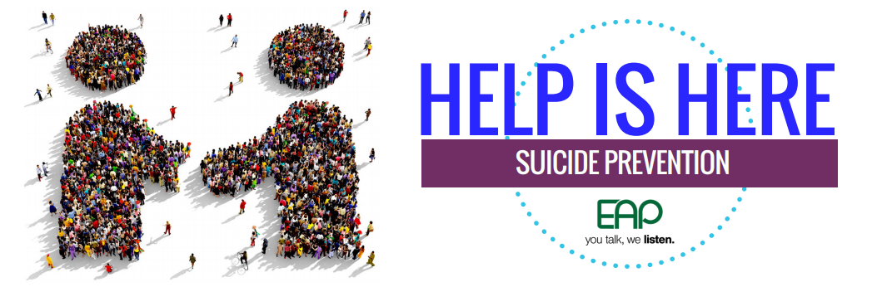
As noted in the news recently, the threat of suicide is growing. The incidence of suicide in the United States has increased by 25% since 1999 and suicide prevention strategies are not addressing the threat as well as they should. It is an important time to learn as much as we can to promote prevention, in our personal lives as well as our professional lives.
SITUATIONS THAT CONTRIBUTE TO SUICIDE RISK
- Relationship problems
- Loss of a relationship
- Substance misuse
- Physical health problems; and
- Stress related to one’s job, finances, legal issues or housing problems
SUICIDE WARNING SIGNS
- Talking about wanting to die or wanting to kill themselves
- Depressive symptoms such as sadness, isolation, withdrawal
- Expressing how they feel like a burden to others
- Alcohol and drug abuse
IF YOU KNOW OF SOMEONE WHO IS EXHIBITING THE SIGNS ABOVE, ACT IMMEDIATELY:
- ASK: “Are you thinking of killing yourself?” By asking directly you are creating the space for the person to be honest and express how they feel.
- PROMOTE SAFETY: If the person has confirmed that he or she is thinking about suicide, try to assess their plan. Continue to ask, “Do you have a plan to kill yourself?” If yes call 911 or escort the person to an emergency room ASAP.
- BE A SUPPORT: Listen and express care and concern. Offering a connection can be a tremendous help. Be sure to avoid offering support if you can’t follow through.
- CONNECT: Help is available, but the person may not be able to reach out themselves. Be sure to help them connect to resources, both personal and professional. Several resources are noted below.
- FOLLOW UP: Although the direct threat may be over, a person who has considered suicide may consider again. Expressing ongoing support helps the person feel more connected over time.
Don’t keep it a secret or try to handle on your own. Reach out if you know of anyone who needs help.

The New York City Employee Assistance Program (NYC EAP) offers free and confidential resources, support, and referrals to employees and their family members. Contact the EAP at 212-306-7660 or by email at eap@olr.nyc.gov.

NYC Well counselors are also available to help 24/7/365. Call 888-NYC-Well, text WELL to 65173 or visit www.nyc.gov/nycwell to chat online.
- National Suicide Prevention Lifeline 1-800-273-TALK (8255).
- Center for Disease Control: Preventing Suicide: A Technical Package of Policy, Programs, and Practices
- Suicide Prevention Resource Center
- Suicide Prevention Center of New York State
- For more information on how to make a difference, visit the website: Be the one to save a life at http://www.bethe1to.com/

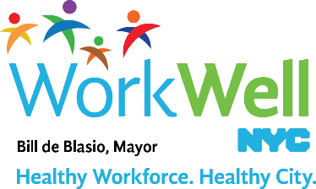
www.nyc.gov/workwellnyc | workwell@olr.nyc.gov

