**[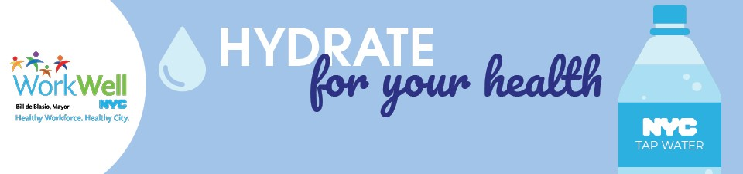](https://on.nyc.gov/2KTYE6l)**

**Summer is here and staying hydrated is an important part of being your healthiest! Make sure you drink plenty of water and enjoy fresh fruits and vegetables.**

* In the summer it is especially important to stay hydrated. Water helps keep your body temperature normal and helps muscles work efficiently.
* Eat fruits and vegetables every day. They’re naturally low in sodium and can lower your risk of heart disease and possibly some cancers.

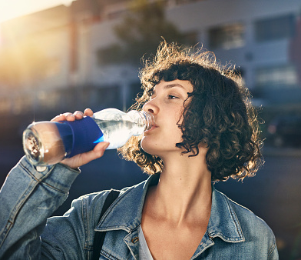

**Make It Convenient**

* Carry a reusable bottle with you and refill it at water fountains.
* Ask your agency’s facilities personnel for permission to post this [water fountain prompt sign](https://on.nyc.gov/2Nhc3Xu) in your office.

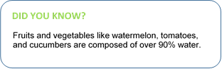**Make It Your Way**

* If you are craving some fizz, try seltzer. Pick your favorite flavor or add a splash of 100 percent fruit juice.
* Give your water some flavor! Add fresh fruits and herbs to your water. Use this Use this [flavor-infused water recipe.](https://on.nyc.gov/2KpbFs5)

**Make a Plan**

* Make half your plate fruits and vegetables. Check out the [Guide to Healthy Eating and Active Living in NYC](http://on.nyc.gov/2hFu56T) and the [Eating Healthy website](https://on.nyc.gov/2tM1uDB) for tips and resources on how to do this.
* Find a farmers market near you. Text “SoGood” to 877877 or use this [map](http://on.nyc.gov/2yY1Fkc) to find a farmers market near you.



[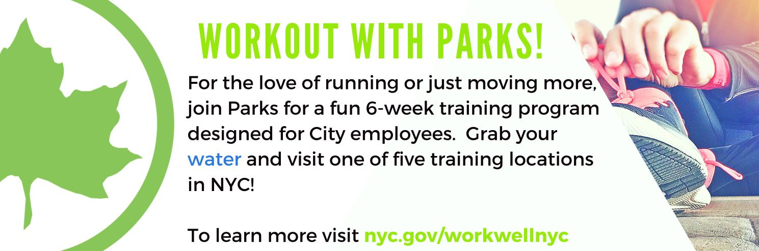](https://on.nyc.gov/2zDQb6b)

To learn more about healthy summer living strategies and tips, visit [**WorkWell NYC**](https://on.nyc.gov/2KTYE6l).

[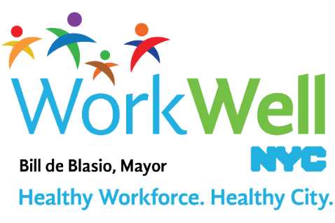](http://on.nyc.gov/2AFumj1)

[www.nyc.gov/workwellnyc](http://on.nyc.gov/2AFumj1) | [workwell@olr.nyc.gov](mailto:workwell@olr.nyc.gov)