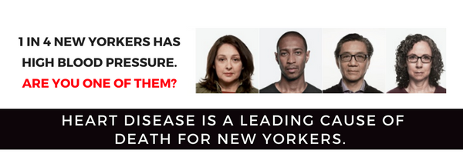
YOU CAN REDUCE YOUR RISK.

TAKE THE FOLLOWING 6 STEPS TO IMPROVE YOUR HEART HEALTH:
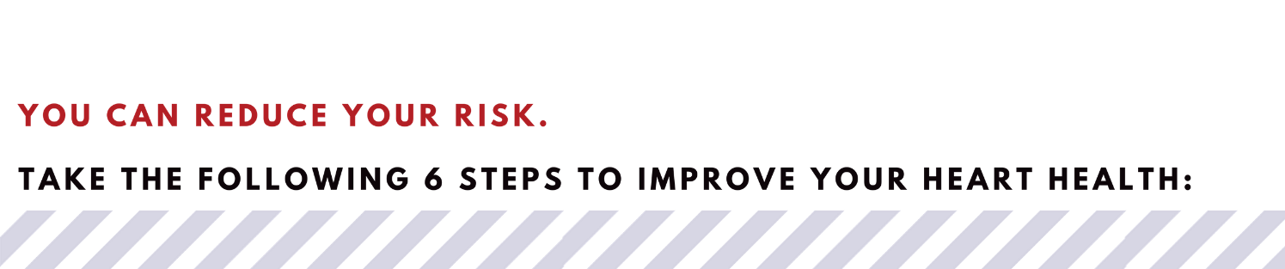
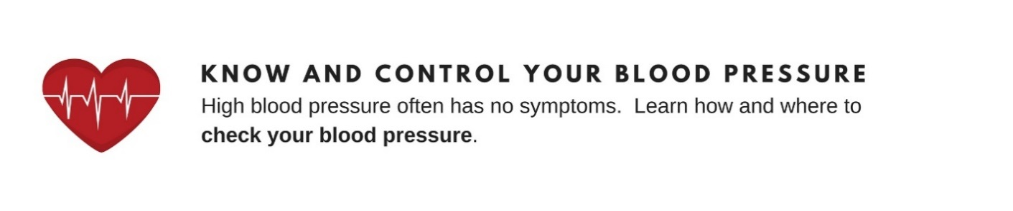 | KNOW AND CONTROL YOUR BLOOD PRESSURE  High blood pressure often has no symptoms. Learn how and where to check your blood pressure.
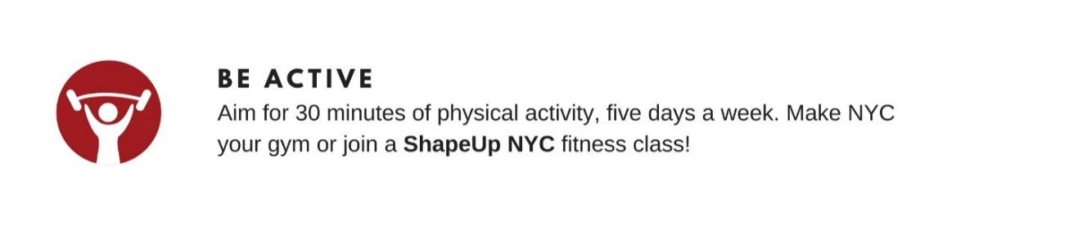 | BE ACTIVE  Aim for 30 minutes of physical activity, five days a week. Make NYC your gym or join a Shape Up NYC fitness class!
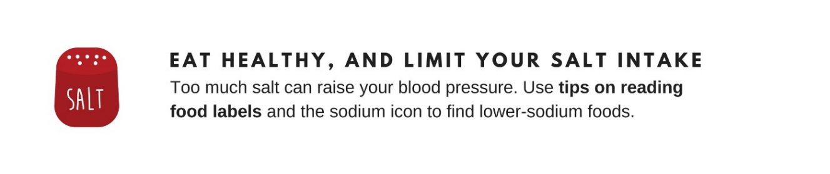 | EAT HEALTHY, AND LIMIT YOUR SALT INTAKE  Too much salt can raise your blood pressure. Use food labels and the sodium icon to find lower-sodium foods.
 | LIMIT YOUR DRINKING  Stick to 1 drink a day for women or 2 drinks a day for men.  Concerned about risky drinking? Seek support for you or a loved one with the NYC Employee Assistance Program (EAP).
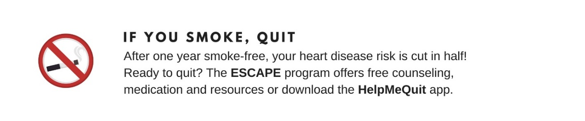 | IF YOU SMOKE, QUIT  After one year smoke-free, your heart disease risk is cut in half!  Ready to quit? The ESCAPE program offers free counseling and medication.
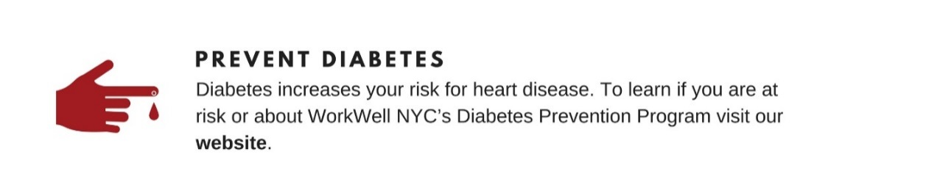 | PREVENT DIABETES  Diabetes increases your risk for heart disease. Find out if you are at risk and learn about WorkWell NYC’s Diabetes Prevention Program (DPP).
WorkWell NYC is here to help! Visit bit.ly/HeartHealthMonthNYC for resources and programs to help keep your heart healthy.

