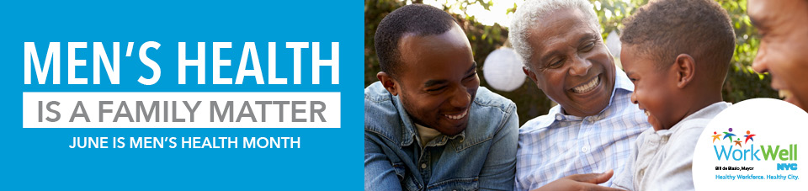
June is Men’s Health Month, and with Father’s Day this weekend, now is a great time for men and their families to talk about men’s health! WorkWell NYC’s free resources can help men improve their health. Set an example by making healthy choices yourself.

Get Regular Checkups
One in five men in NYC don’t have a personal health care provider - a network of providers is available!
Visit a health care provider for regular checkups to help you stay healthy. Don’t have a personal health care provider? Call the number on the back of your health insurance card or visit your health plan website to find one in your network.

Quit Smoking
One in six men smoke - free counselors and resources to help quit smoking are available!
Use these free resources to quit smoking, including the HelpMeQuit app, which you can use anytime on your phone. Some people find that one-on-one support with a coach can help as well—the Employee Smoking Cessation Assistance Program (ESCAPE) is available to all employees and their household members.

Seek Support When You Need It
One in five men binge drink** and men in NYC are four times more likely to die from heroin or fentanyl overdose than women - free worksite and community resources are available!
- The New York City Employee Assistance Program (NYC EAP) offers free and confidential resources, support, and referrals to employees and their family members. Contact the EAP at 212-306-7660 or by email at eap@olr.nyc.gov.
- NYC Well counselors are also available to help 24/7/365. Call 888-NYC-Well, text WELL to 65173 or visit nyc.gov/nycwell to chat online.
- Use the Stop OD NYC app to learn more about fentanyl and other opioids, and how to save a life with naloxone.
- Your health care provider can also offer information and help.
**Binge drinking is defined as five or more drinks on one occasion for men and four or more drinks on one occasion for women in the past 30 days.

Eat Healthy and Stay Active
Less than 1 in 10 men in NYC eat the recommended five or more servings of fruits and vegetables each day - free recipes and resources are available!
- Check out the Guide to Healthy Eating and Active Living in NYC to learn how to create healthy eating habits and try one of these healthy recipes.
- Learn tips on reading food labels and use the sodium icon on chain restaurant menus to find lower-sodium (salt) foods. Men are more likely to exceed the recommended sodium intake than women, increasing their risk for high blood pressure, heart disease and stroke.

To learn more about men’s health resources and tips, visit WorkWell NYC.

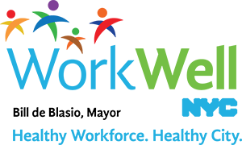
www.nyc.gov/workwellnyc | workwell@olr.nyc.gov

