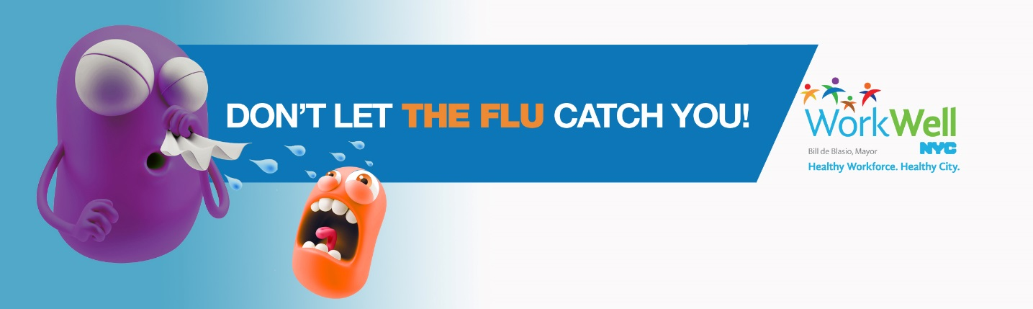

Time is running out – don’t miss your chance to get your free flu shot!

Flu season is here, so protect yourself, your family, and your community by getting your flu shot. It’s a quick and easy way to help keep NYC flu-free! Worksite flu shot clinics are available throughout the city. New clinics are added daily, so check the schedule and book your appointment today!

Blood pressure screenings will also be available at the DCAS flu shot clinics on 11/6 and 11/20.

Check your choice:



There are four convenient ways to get your flu shot.

Which is best for you?

(Select below)



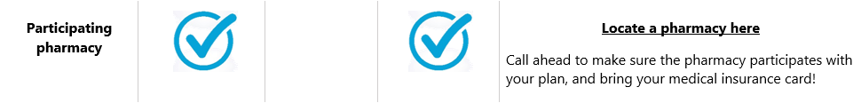

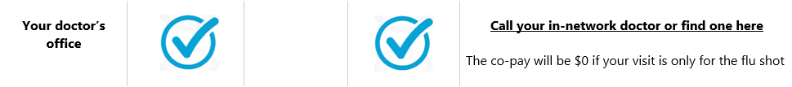

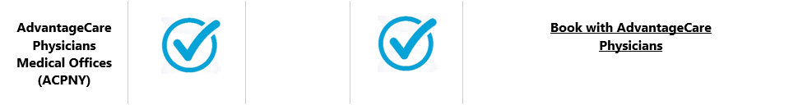

Don’t let the flu catch you! Schedule your flu shot today!
Interested in becoming a WorkWell NYC Champion?
Click here to learn more and sign up!

www.nyc.gov/workwellnyc | workwell@olr.nyc.gov

Do not reply to this message.

