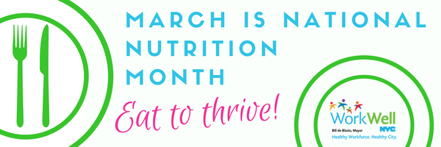
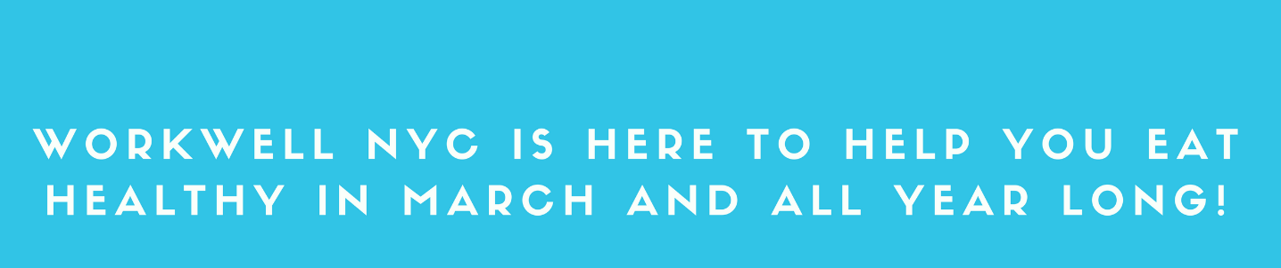
We all have our preferences when it comes to food. WorkWell NYC wants to ensure you are putting your best fork forward when choosing the foods that will fuel your body. Eating healthier can help you have more energy, manage stress, maintain a healthy weight and reduce your risk for chronic diseases like heart disease and diabetes.

Below are a few tips to help keep you on track all day long:
 | ON THE RUN  Take it with you! Pack your lunch and bring easy-to-carry snacks like apples, carrot sticks, or air-popped popcorn  Plan ahead! Prepare and portion out meals in advance, so you can grab-and-go if things are busy.
 | ON A BUDGET  Stock up! Buying in bulk can save you money, especially when there are sales. Cooking at home is usually healthier and less expensive than going out.  Create options! Frozen or low-sodium canned vegetables and fruits have similar benefits to fresh produce, often at a lower price.
 | ON YOUR LUNCH BREAK  Split it up! Restaurant portions are often enough for two! Share your meal with someone or save half for tomorrow. Whether you’re eating out or packing your lunch, fill half your plate with fruits and vegetables.  Put the break back in lunch break! Use your lunch time as a mental reset. Take a few minutes to slow down and enjoy your meal.
For more healthy eating tips, review the healthy eating guide or visit us at nyc.gov/workwellnyc.


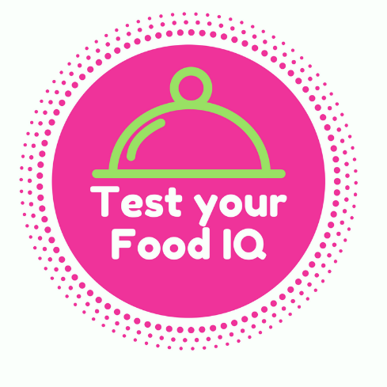 |  | 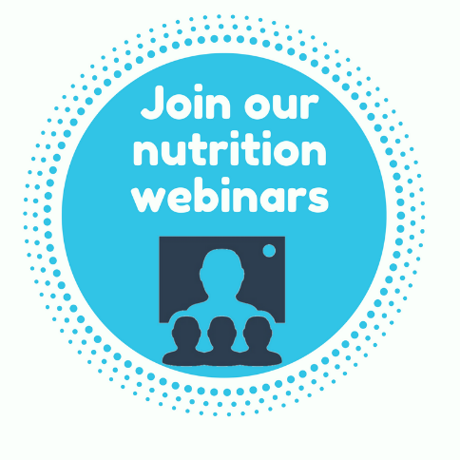 | 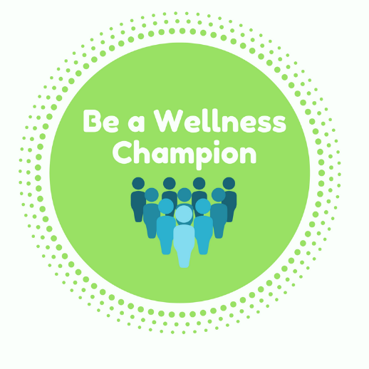
WorkWell NYC Webinar Wednesdays:

- Nurtition 101: Basic Strategies for Healthy Eating | March 7 | 12:30PM
- Making Meals Fun: Mealtimes with Young Children |March 14 | 1:00PM
- What’s in Your Food? Reading and Understanding Food Labels | March 21 | 1:00PM
- Sip This, Not That: Exploring the Advantages of Healthy Beverages | March 28 | 12:30PM



