Today is **World No Tobacco Day**. Join this global movement to quit or encourage others to quit smoking!

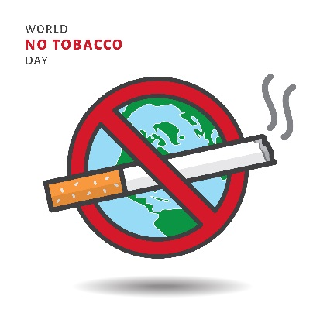

Nearly two-thirds of NYC smokers [try to quit](http://bit.ly/2IjKsGx) every year. If you’ve been thinking about quitting and haven’t been able to do so on your own, try quitting together with others today



**Reasons to Quit**

* Have more energy
* Feel better
* Take better care of your teeth
* Save money
* Have a healthier and longer life

**Resources to Quit**

* ****Need help? Call 347-396-4403 to enroll in the Employee Smoking Cessation Assistance Program ([ESCAPE](http://on.nyc.gov/2mpwSa6)), which is available for **all** New York City government employees and their household members. ESCAPE offers the following quit-smoking support, **free** of charge:
* Medications, including nicotine patches, gum and lozenges, Zyban (bupropion) and Chantix (varenicline)
* Confidential counseling provided by trained specialists in-person or by phone
* The new [NYC HelpMeQuit app](http://bit.ly/2Gj7Cqo) is a great tool to help you finally say goodbye to cigarettes. Download now for **free** at the Apple ([iOS](https://apple.co/2KtML6b)) or Google Play ([Android](http://bit.ly/2rMb0F5)) app stores, and share with others.
* Coping with stress without smoking can be tough, but here are some helpful [tips and strategies](http://bit.ly/2rGaI2y). Keep trying; quitting is hard, but each try is progress.
* Talk to your regular health care provider about quitting smoking. If you don’t have a regular health care provider, call the number on the back of your health insurance card or visit your health plan [website](http://on.nyc.gov/2FxPhHg) to find one in your network.
* Visit [WorkWell NYC](http://on.nyc.gov/2FSbwuw) to learn more about resources to quit smoking.

[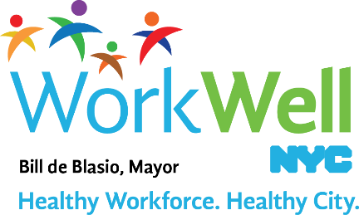](http://www.nyc.gov/workwellnyc)

[nyc.gov/workwellnyc](http://on.nyc.gov/2AFumj1) | [workwell@olr.nyc.gov](mailto:workwell@olr.nyc.gov)