Enjoy the summer weather and celebrate **National Great Outdoors Month** and **National Safety Month**! Take some time this June to start a regular outdoor physical activity routine. Exercise solo or ask your friends and family to join!

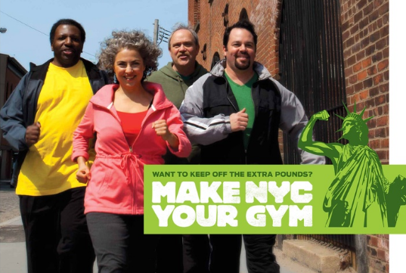In honor of **National Great Outdoors Month,** here are some exciting and **free ways** to move more:

1. **Shape Up NYC -** Shape Up NYC offers free fitness classes in all five boroughs, including outdoor classes during the summer. Registration is not required. Find a workout class at [nyc.gov/shapeupnyc](http://www.nyc.gov/shapeupnyc).
2. [**Make NYC Your Gym**](http://www1.nyc.gov/assets/doh/downloads/pdf/public/dohmhnews10-02.pdf) **–** Hike to some of NYC’s [landmarks](http://www1.nyc.gov/site/lpc/designations/maps.page) along thousands of miles of sidewalks, walkways and [green spaces](http://www.nyc.gov/parks).
3. **Hop on a Bike** - Biking is a fun, convenient and cheap way to get around the city. Remember to wear a helmet! Call 311 to get a free helmet for yourself or your child. To learn more, visit [www.nyc.gov/dot](http://www.nyc.gov/dot) and search “Bicyclists.”

In honor of **National Safety Month**, **here are some tips for making every trip a safe trip:**

1. When **driving**, slow down, yield to pedestrians and focus on the road. Follow NYC’s default speed limit of 25 mph. Don’t talk or text on your cell phone.
2. When **biking**, ride in the direction of traffic, follow traffic signals and make sure others can see you. Wear something bright or reflective and use a white headlight and red taillight, as required by law.
3. When **walking**, watch for turning cars and look in all directions before crossing the street.

To learn more about NYC’s plan to reduce road deaths to zero, visit [nyc.gov/visionzero](http://www.nyc.gov/visionzero).

[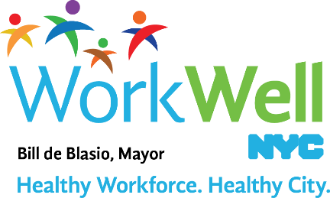](http://www.nyc.gov/workwellnyc)

[www.nyc.gov/workwellnyc](http://www.nyc.gov/workwellnyc) | [workwell@olr.nyc.gov](mailto:workwell@olr.nyc.gov)