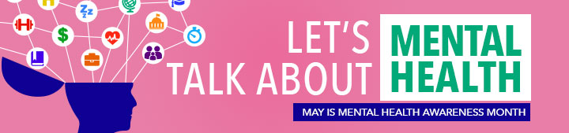
Learn some strategies to help you choose the best words to support someone who may be dealing with a mental health issue.
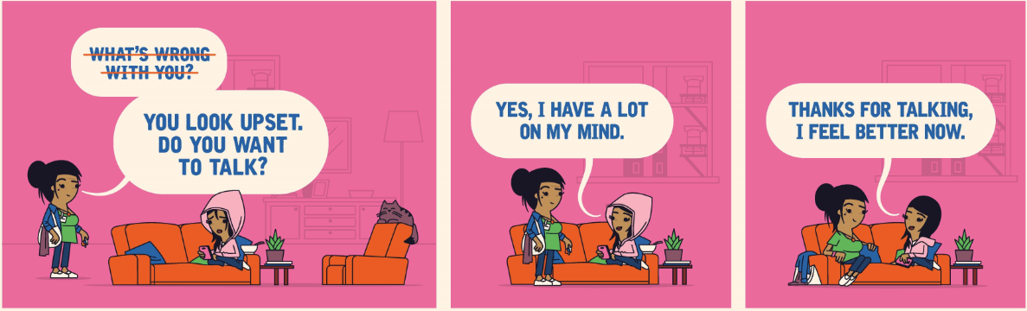
Helpful things to say to someone who may be dealing with a mental health issue:
- “It is hard for me to understand exactly what you are going through, but I can see that it’s distressing for you.”
- “Something seems to be bothering you. Do you want to talk about it?”
- “I would like to help you. Can you tell me what might be helpful?”
- “If you don’t feel comfortable talking with me, I know other resources that might help.”

Things to consider when starting a conversation about mental health issues:
- Offer emotional support and encouragement, and be patient.
- Encourage the person to find and stick with treatment.
- Don’t dismiss negative feelings or blame the person.
- Invite the person to join you in an activity, such as taking a walk or getting a coffee/tea — but don’t take it personally if they turn you down.
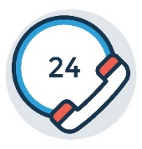 | Need support for yourself or a loved one?
 | The New York City Employee Assistance Program (EAP) offers free and confidential resources, support, and referrals to employees and their family members. Call 212-306-7660, email eap@olr.nyc.gov or visit nyc.gov/eap to learn more.
 | NYC Well counselors are available to help 24/7/365. Call 888-NYC-WELL (888-692-9355), text WELL to 65173 or visit nyc.gov/nycwell to chat online.
 | Your regular health care provider can also offer information and help. If you don’t have a regular health care provider, call the number on the back of your health insurance card or visit your health plan website to find one in your network.
Visit our website to learn more mental health well-being strategies and tips.
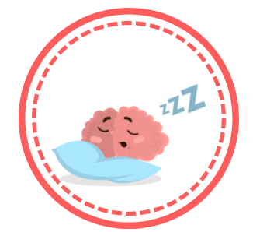 | SAVE THE DATE! Join WorkWell NYC and the NYC EAP for two lunchtime webinars in recognition of Mental Health Awareness Month.  - May 9th | 12:30PM: Myth Busting – The Facts about Mental Wellness  Register at: bit.ly/MythbustingWebinar  - May 23rd | 12:30PM: What’s the Big Deal About Sleep?  Register at: bit.ly/WorkWellSleeps
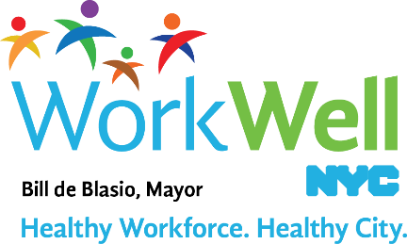
nyc.gov/workwellnyc | workwell@olr.nyc.gov

