
FLU SEASON IS HERE.

Protect yourself.
Protect your family.
Across the state, more than 1,600 New Yorkers were hospitalized for flu in just one week. WorkWell NYC wants you to be protected by reminding you that it’s not too late to receive a flu shot. Don’t let the flu catch you too!
Here are three convenient ways to get you and your family protected with a $0 copay flu shot:
Drop in at a participating pharmacy
Make an appointment with your in-network doctor
Schedule an appointment with AdvantageCare Physicians

Here are a few answers to your frequently asked questions about the flu shot.

For more information, visit the WorkWell NYC flu page.
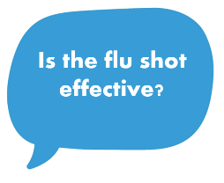 | The flu shot is the most effective way to protect yourself and your loved ones from getting the flu and spreading it to others around you.
 | Anyone can get very sick from the flu virus, including healthy people. By getting the flu shot, you are protecting yourself and your loved ones.
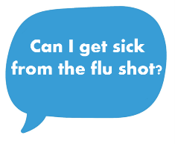 | You cannot get the flu from the flu shot. However, some people experience mild side effects such as soreness, redness and swelling where the shot was given.


