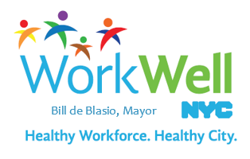

 A reminder from [WorkWell NYC](http://www1.nyc.gov/site/olr/wellness/wellnesshome.page): you have the power to make small changes that can improve your health! Check out the new [Guide to Healthy Eating & Active Living in NYC](http://www1.nyc.gov/assets/doh/downloads/pdf/cdp/healthy-eating-active-living-guide.pdf) to learn simple steps for creating healthy habits.

Try these three easy steps to increase your fruit and vegetable consumption!

**#1: Include fruits and vegetables as a key part of your heart-healthy diet.** They contain vitamins and minerals, as well as fiber, which helps you feel full on fewer calories. At meals, make 1/2 your plate fruits and vegetables, and enjoy them as a snack or even on the go.  Bananas, apples, baby carrots and sliced peppers are great options to carry with you.

**#2: Visit your local farmers’ markets to buy fresh and affordable produce** while supporting local farmers. A wide variety of delicious produce is in season now in our region, including tomatoes, collard greens, summer squash, berries, and more! Text “SoGood” to 877877 or use this [map](http://www1.nyc.gov/assets/doh/downloads/pdf/cdp/farmers-market-map.pdf) to find a farmers’ market near you.

**#3: Attend a free healthy cooking class at a farmers’ market** provided by the NYC Department of Health & Mental Hygiene’s [Stellar Farmers’ Market](http://www1.nyc.gov/site/doh/health/health-topics/cdp-farmersmarkets.page) program. You can try a new fruit or vegetable and learn to cook with it. If you’re not able to attend a class, download these healthy [recipes](http://www1.nyc.gov/assets/doh/downloads/pdf/cdp/stellar-farmers-markets-recipes.pdf) and get [tips](http://www1.nyc.gov/assets/doh/downloads/pdf/cdp/healthy-eating-active-living-guide.pdf) on incorporating more fruits and vegetables into your day.

Stay tuned for regular [WorkWell NYC](http://www1.nyc.gov/site/olr/wellness/wellnesshome.page) emails like this one, which will include tips on a variety of health and wellness topics!

