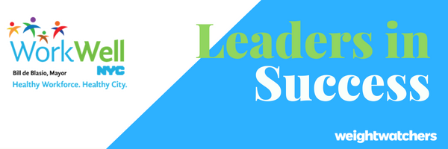
For more than 2 years, colleagues across the five boroughs have come together and lost more than 90,800 pounds through participation in Weight Watchers. Here’s how some leaders across the city have made small changes that led to big results!

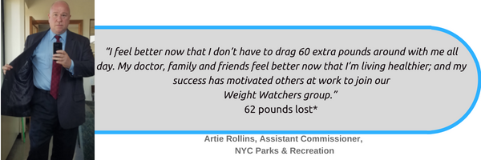
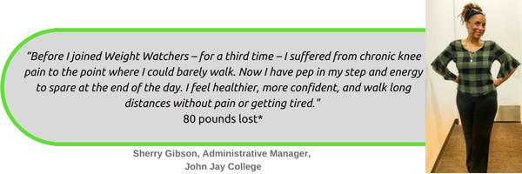
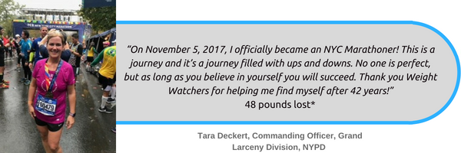
Read Artie, Sherry and Tara’s full stories add link. Join in their success by visiting http://nyc.join.weightwatchers.com to sign up today. Employees can take advantage of a subsidy that reduces the cost of membership by more than 50% off the regular membership price**. Spouses/domestic partners, dependents (ages 18-26) and retirees† are also eligible for discounted pricing through the WorkWell NYC partnership with Weight Watchers – making health a family affair!

Weight Watchers Offering | NYC Employee Special Pricing
Meetings (Includes OnlinePlus) at work or in your local community | $15.00 per month
OnlinePlus | $7.00 per month

Find an At-Work Meeting near you!
There are currently 100 At-Work meetings happening throughout NYC!
Visit http://www1.nyc.gov/site/olr/wellness/wellness-atworkmeetings.page to locate a meeting near you.

Are you already at WW Member?
Invite a friend from work to join now through December 31st and you’ll both receive a FREE 6-month subscription (3-issues) to Weight Watchers Magazine***. The more colleagues you sign up, the longer the magazine subscription you’ll receive. Visit www.weightwatchers.com/us/invite to send your colleague an invitation join.

Do you have a success story to share?
We want to hear from you! Share your journey and be inspired by others using #WWorkWell in your Connect‡ posts and WWorkWell in your Connect tagline.

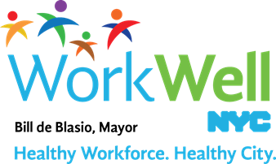

www.nyc.gov/workwellnyc || workwell@olr.nyc.gov

* People following the Weight Watchers plan can expect to lose 1-2 lbs/week.
** The dollar value of this contribution/benefit will be included as taxable income to the employee.
† Spouses and dependents of retirees are not eligible for the subsidy.

*** Magazine Subscription: Joining member must purchase an At Work Meeting Series, Meetings + OnlinePlus or OnlinePlus subscription through current and joining members’ employer or health plan in participating areas only by 12/31/18 and continue the Weight Watchers membership for at least 2 weeks. Referring member must have a current At Work Meeting Series, Meetings + OnlinePlus or OnlinePlus subscription enrolled through their employer or health plan that has been active for a minimum of 2 weeks. Joining member must not have had an active Weight Watchers At Work Meeting Series or Weight Watchers subscription for at least 1 month. Offer good for U.S. addresses only. First issue will arrive within 4-6 weeks after joining and current members receive emails confirming eligibility.

‡ WorkWell NYC, The Mayor's Office of Labor Relations or The City of New York are not responsible for material posted to this social media site and do not guarantee the content, accuracy, or use of the content in this site. WorkWell NYC, The Mayor's Office of Labor Relations or The City of New York do not in any way endorse or recommend individuals, products or services that may be discussed on this site. WorkWell NYC, The Mayor's Office of Labor Relations and The City of New York specifically disclaims all liability for claims or damages that may result from any posting on this site. WorkWell NYC, The Mayor's Office of Labor Relations and The City of New York accepts no responsibility for the opinions and information posted on this forum, and such opinions do not reflect the policies of WorkWell NYC, The Mayor's Office of Labor Relations or The City of New York. In no event shall WorkWell NYC, The Mayor's Office of Labor Relations or The City of New York be liable to you or anyone else for any decision made or action taken by you in reliance on information on this site

.

