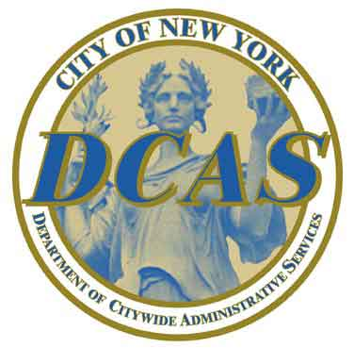
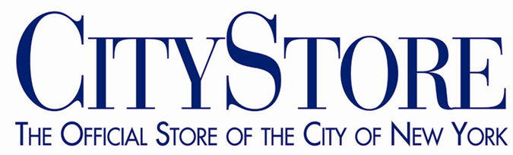


PRESS RELEASE

For Immediate Release
September 5, 2006
www.nyc.gov/tv
www.nyc.gov/dcas

Popular NYC TV Shows To Be Available on DVD
Special Collections of 3 Shows will be sold by CityStore,
the Official Store of the City of New York

The first-ever collections of NYC TV’s award-winning programming will be available on DVD exclusively through CityStore, the Official Store of the City of New York. CityStore will offer collections of three top-rated programs -- “Secrets of New York.” “Cool in Your Code,” and “Blueprint NYC” -- at a special price of $9.95 plus shipping and handling. Each DVD includes at least four half-hour episodes, plus extra features.

The DVD collections will allow a wider audience to see the best that New York City has to offer, through the best episodes of three informative, entertaining NYC TV shows. “Secrets of New York” has won one New York Emmy Award and five Telly Awards for outstanding local cable programming. “Cool in Your Code” has won two New York Emmy Awards, and “Blueprint NYC” has won five New York Emmy Awards and two Telly Awards.

"Never before has it been so easy to share New York City with friends and family," said Arick Wierson, the General Manager of NYC TV. “These DVDs are wonderful gift items that will be watched over and over."

“With these DVDs, we will be able to offer a glimpse of ‘Everything New York’ to all New Yorkers at heart, wherever they may be,” said Commissioner Martha K. Hirst of the Department of Citywide Administrative Services, which operates CityStore.

The show collections available in this initial offering are:

- “Secrets of New York” – Host Kelly Choi explores the wonder and mystery of New York City by unveiling some of the City’s best-kept secrets. The DVD includes four favorite episodes: “Deep New York: How Low Can You Go in the Big Apple?” “Secrets in the Sky: The Towers of Gotham,” “Ancient New York: 400 Years and Counting” and “Jails of New York.” Bonus material includes a director’s audio commentary, behind-the-scenes photo gallery, trailer, demo reel and DVD promos.
(more)

- “Cool in Your Code” – Emmy-award-winning host Hank Wasiak and Shirley Rumierk showcase what’s cool, new, undiscovered and different throughout New York City’s more than 200 zip codes in this half-hour show, produced in conjunction with the Concept Farm. The DVD collects four favorite episodes, covering what’s cool in Hell’s Kitchen, Manhattan; Long Island City, Queens; Greenpoint, Brooklyn; and the Bronx. Special features include never-before-seen footage, outtakes, montages, promos and a demo reel.

- “Blueprint NYC” – takes viewers in and around the iconic structures and landmarks that grab the attention of visitors and native New Yorkers alike. The DVD collects five favorite episodes of this Emmy-award winning program, with visits to City Hall, Gracie Mansion, Coney Island, the Brooklyn Botanic Garden and Snug Harbor. Bonus material includes a director’s audio commentary, a behind-the-scenes photo gallery, demo reel and DVD promos.

To order the new DVDs, visit www.nyc.gov/tvstore or call 311 (212-NEW-YORK outside New York City) and ask for “NYC TV DVDs.” Later this fall, the DVDs will be available at CityStore, located in the Manhattan Municipal Building in lower Manhattan (1 Centre Street, open Monday through Friday, 9 a.m. to 4:30 p.m.).

The DVD collections are the newest outlet for NYC TV’s innovative programming, which airs on NYC TV Channel 25. This fall, WNBC Channel 4 in New York will air more than 100 episodes of NYC TV shows in the 11 a.m. to 12:00 p.m. time slot. Also this fall, four episodes of “Secrets of New York” will air nationwide on PBS stations. An informational spot touting the DVD collections will air immediately after each show.

NYC TV shows can also be seen on WVVH-TV, Hamptons TV, weekdays from 1-3 pm with an encore from 1-2 am. Hamptons TV is the largest FCC licensed TV station in Suffolk County, broadcasting on Cablevision Channel 78 and UHF Channel 50.

With its signature theme “Everything New York,” NYC TV’s flagship Channel 25 showcases New York culture, from entertainment, fashion and music to food, history and landmarks. NYC TV also operates four other channels: City Drive Live (Channel 72 on Cablevision, 93 on Time Warner, and digital broadcast Channel 25.2), with 24/7 live coverage of the City’s main roadways through the Department of Transportation’s network of traffic cameras; Channel 74, with mayoral press conferences, City Council hearings, and other municipal services information; Channel 73, with programming of special interest for the City’s diverse immigrant communities; and Off Track Betting broadcast live on NYC TV Channel 71.

CityStore is the City of New York’s home for exclusive gift items, clothing and accessories featuring the City Seal, official FDNY and NYPD merchandise, and more. All proceeds go to the City of New York’s General Fund, which funds all government activities. To view the full catalog of CityStore items, visit www.nyc.gov/citystore.

# # #

Contact: Timi Lewis (NYC TV) (212) 669-7653
Mark Daly (DCAS) (212) 669-7140

