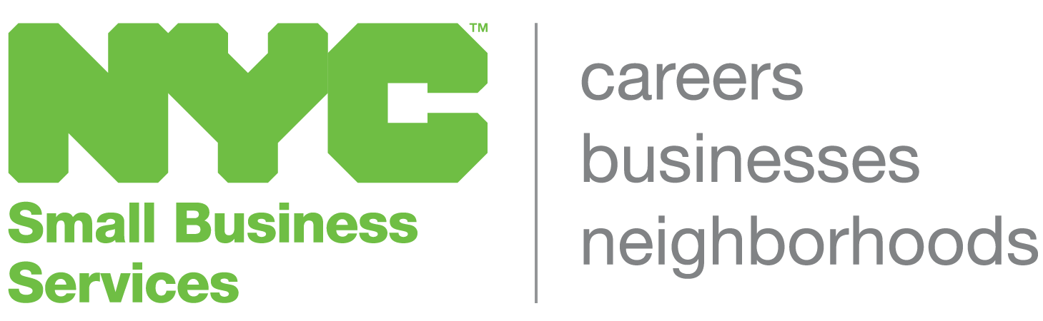

SAMPLE VISION STATEMENT

FOR THE PROPOSED NYC BUSINESS IMPROVEMENT DISTRICT

Last Updated: 11/7/2016

Adopted at the meeting of the NYC BID Steering Committee on [date]:

We, the members of the steering committee of the proposed NYC Business Improvement District, represent a comprehensive array of stakeholders and leadership from NYC who have united in order to address the common problems and chronic quality-of-life issues that affect the properties and businesses in NYC’s primary business district.

In recent years, the residential blocks of NYC have experienced significant renewal and reinvestment, while economic progress, activity and private investment have lagged in the adjacent commercial area. Some of the problems that have contributed to the slow revival of the business area include: a lack of parking resources, chronic criminal activity, the distressed appearance of the district’s storefronts and streetscape and an imbalanced mix of retail and service businesses.

Notwithstanding these challenges, the NYC Business District is endowed with numerous assets not typically found in neighborhood commercial areas, including: excellent public transit access, heavy pedestrian traffic, a central location, a strong and diverse small business community and cultural institutions.

We declare that the NYC Business District is the business and cultural destination of choice for all residents of NYC.

Through the services of the BID, we are committed to:

- A safe, clean and aesthetically attractive commercial and cultural destination;
- Fostering thriving and profitable businesses;
- Providing a variety of retail goods and services from a mixture of national brand and locally-based companies, including minority and women-owned small businesses;
- Valuing the diverse history, culture and styles of the residents of the NYC communities by offering goods and services that respond to the community’s desires

The Vision Statement was crafted from the following responses provided by members of the BID Steering Committee.

- Why have you joined the BID Steering Committee?

  - Multiple aligned interests in the community as all members are stakeholders (Resident, Business Owner, Property Owner, Home Owner, Consumer, Worker and Religious Worshipper) of the NYC Community
  - Recognize the potential that the district has (housing stock, small businesses, transportation, foot traffic, etc.) and excited about realizing the development opportunities that exist. Especially economic development that will stimulate, strengthen and sustain the overall needs of the community
  - Professionals ready and willing to give their thoughts and opinions as a representative of the community; as well as their skills and resources (expertise, networks) to aid in the manifestation of an improved community through the BID
  - Want to see the area blossom into a commercial district that offers a diversity of services, while simultaneously want to ensure the survival of small businesses by finding the balance between the preservation of the history, character, and vitality of our neighborhood so not to be overshadowed by big box development
  - Desire to be a part of the revitalization of the commercial district in order to help improve the quality of life and the business environment of the community
  - Interested in the understanding of the BID process and how it works with business owners to make improvements (streetscape, store façade, safety, etc.) for an enhanced shopping district

- What kind of place do you want the NYC Business District to be?

- A safe, clean, attractive and welcoming shopping destination with its own unique style, for residents and nonresidents, that offers a variety of retail and service options through a mixture of small family owned boutiques/businesses and major brand companies
- A place with a range of services affordable to a range of income levels
- A more beautified area through lighting, signage, sanitation, benches, planters, flags, etc. where people can spend time lounging and window shopping
- A viable shopping district with quality businesses

- What is the business district’s greatest potential?

- Diversity of cultures and history of the neighborhood
- Heavy pedestrian traffic and the arteries of transportation that currently exist
- Density in the area, which is high but could be higher
- Engagement of community members, especially merchants and property owners
- Approaching the many major companies that currently exist within the community to leverage their support for the revitalization of the district
- To generate greater spending in the community by attracting a more diverse group of retailers that will target various demographic groups that are currently spending much of their purchasing power outside of the community

- Which goals for the district are most widely held?

- Safety, cleanliness and beautification
- New business development and support of locally owned businesses to result in a business district that offers an assortment of shops, restaurants and cafes
- More healthy food choices
- Full cooperation from merchants, property owners, elected officials, and City Agencies

